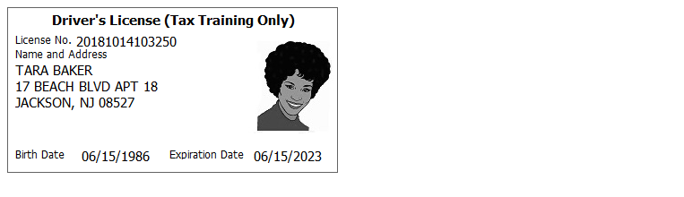
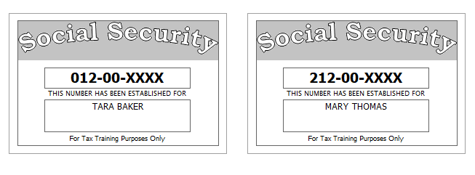

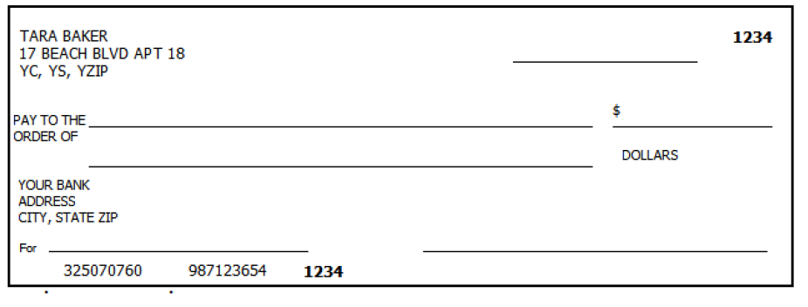
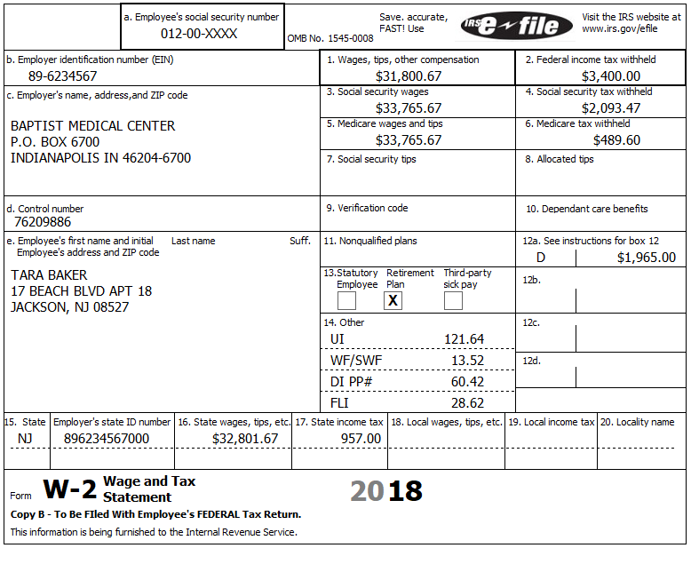
67890123
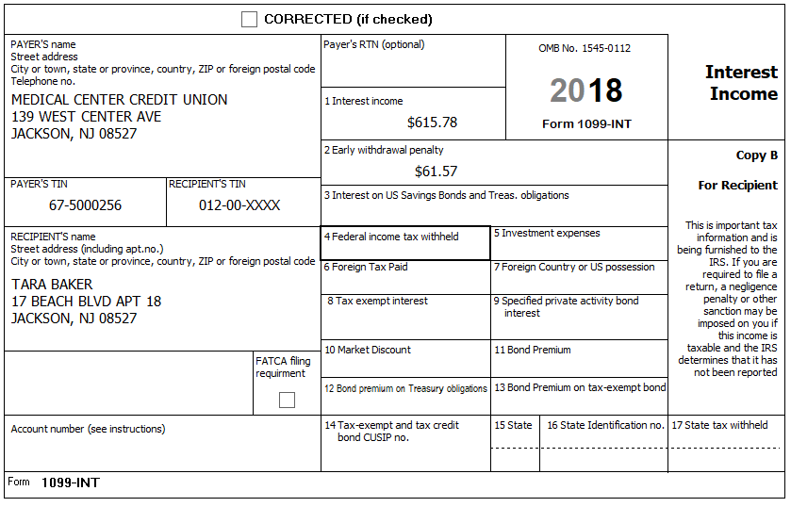

Tara was seriously injured in a car accident and became eligible for a disability pension in December of 2018. The 1099-R shows the following:
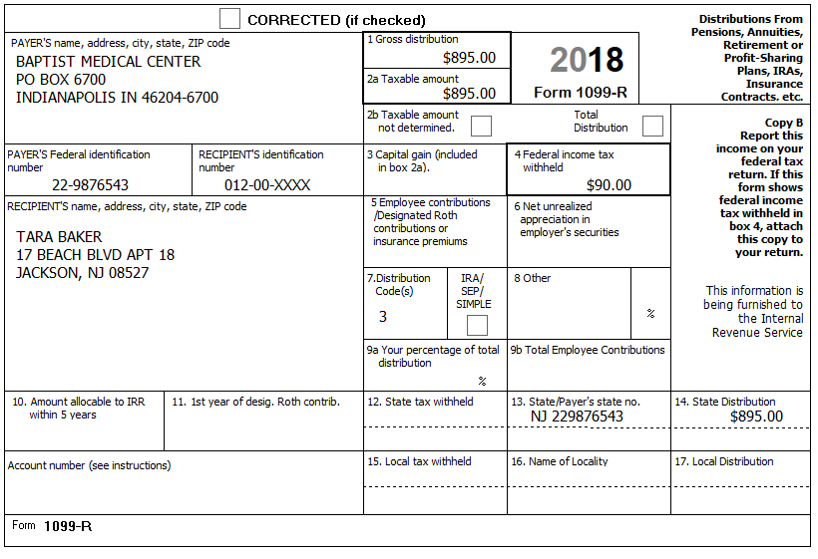

Tara was lucky one day at the Gambler’s Row Casino, winning $2,500; she has records indicating that she has $2,300 in losses.
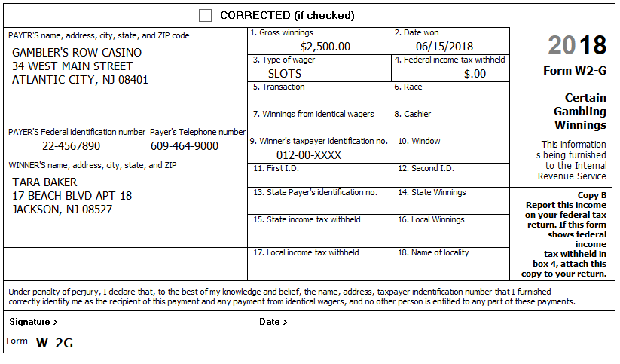

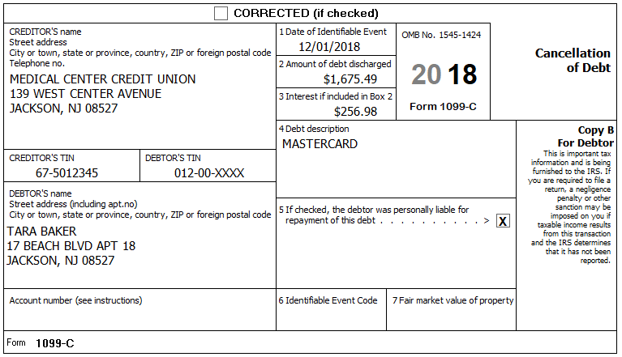

While she worked, her daughter attended the Clark County After School Program. Tara has the receipt and all pertinent information.
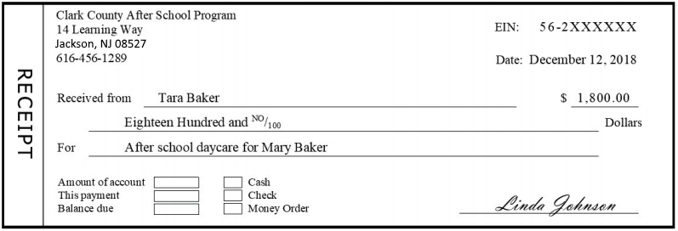
56-2000752

Other Information:
- Tara paid $400 a month for rent
- Tara was reimbursed $1000 from her employer’s FSA plan (as a distribution)
- Tara wishes to have her refund or balance due treated the same way for Federal and NJ.
- Tara does not wish to contribute to either the presidential nor gubernatorial election funds
- Last year, Tara had a balance due on her NJ return of $165 which she paid.

Prior Year Return
- Tara did not bring her prior year return, so you ask a few questions:
  - Were things pretty much the same as this year?
  - Did you itemize?
    - Tara says No

Health Care Supplement

Come back and do this after Health Care training

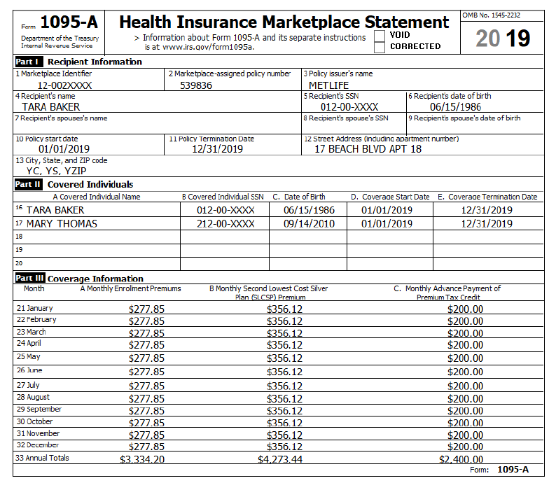
Jackson, NJ 08527

